Hospitality and Tourism

Professional Selling Presentation

Mr. Bodenburg

**THE SITUATION III**

You will assume the role of a sales manager for a convention and visitors bureau of a major city. A potential client is interested in holding its annual conference for 4,000 attendees in your city and is meeting with you to hear about your city’s meeting package. At a minimum, you should discuss convention facilities, hotel package, potential attractions and transportation.

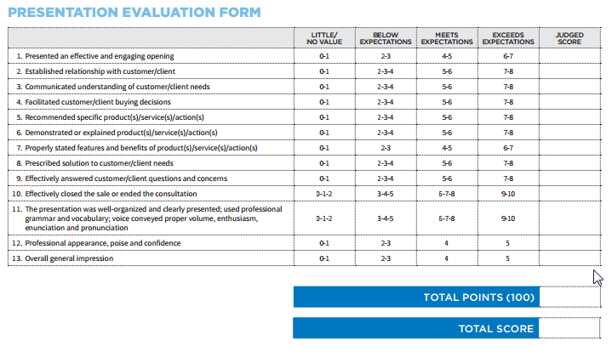

**YOUR ROLE**

* Tout the ability of your city to hold a major conference
  + Describe the convention center facilities
  + Hotels packages near the convention center
  + Transportation
    - To and from the airport
    - Around the city
  + Potential attractions around the city during the annual conference
* The goal is to get a contract signed for the annual meeting to be held in your city